CHAPTER 10
Technology, Production, and Costs
- Chapter Summary
- Learning Objectives
- Chapter Outline
Teaching Tips/Topics for Discussion
- Solved Problems
- Solutions to Review Questions and Problems and Applications

1. Chapter Summary
The basic activity of a firm is to use inputs to produce goods and services. A firm’s technology is the processes it uses to turn inputs into outputs of goods and services. Technological change causes more output to be produced with fewer inputs or the same output to be produced with fewer inputs.
Firms separate the relationship between production and costs into the short run and long run. In the short run, while the firm’s technology and physical plant are fixed, other inputs are variable. In the long run, the firm can vary all inputs, adopt new technology, and change the size of its physical plant.
Total cost is the cost of all of the inputs used in production. In the short run, the costs of fixed inputs are fixed costs and the costs of the variable inputs are variable costs. Total cost (TC) = Fixed Cost (FC) + Variable Cost (VC). When a firm spends money, it incurs an explicit cost. When a firm incurs monetary costs, these are explicit, or accounting, costs. Implicit costs are nommonetary opportunity costs. Economic costs include both accounting and implicit costs.
The firm’s production function is the relationship between the inputs employed by the firm and the maximum output it can produce with those inputs. The production function is short run if the time period is too short to vary at least one of the inputs. The firm’s average total cost (ATC) equals the total cost divided by the quantity of output produced. As production increases from low levels, ATC falls; ATC will rise as output increases further at higher levels of production.
In the short run, adding more and more of a variable input, such as labor, to the same amount of a fixed input, such as capital, will eventually cause the marginal product of the variable product to decline. The initial increase in marginal product of the variable input is due to specialization and the division of labor. The marginal product of labor is the change in output that results from changing the number of workers hired. The average product of labor equals total output divided by the total number of workers hired. When the marginal product of labor is greater than the average product of labor, the average product must be increasing; when the marginal product of labor is less than the average product labor, the average product of labor must be decreasing.
Marginal cost (MC) is the change in total cost from producing one more unit of output. When the marginal product of the variable factor is increasing, marginal cost is decreasing; when the marginal product of the variable factor is decreasing, marginal cost is increasing. Average total cost (ATC) equals TC divided by total output. Average fixed cost (AFC) equals FC divided by total output. Average variable cost (AVC) equals VC divided by total output. ATC = AFC + AVC. When MC is less than ATC or AVC, it causes them to decrease; when MC is greater than ATC and AVC, it causes them to increase. When MC equals ATC or AVC, they are at their minimum values.
In the long run, all costs are variable. Many firms experience economies of scale, which means long run ATC falls as output increases. Constant returns to scale occur when long run ATC is unchanged as output increases. Diseconomies of scale exist when long run ATC rises as output increases.

2. Learning Objectives
Students should be able to:
- Define technology and give examples of technological change.
- Distinguish between the economic short run and the economic long run.
- Understand the relationship between the marginal product of labor and the average product of labor.
- Explain and illustrate the relationship between marginal cost and average total cost.
- Graph average total cost, average variable cost, average fixed costs, and marginal cost.
- Understand how firms use the long-run average cost curve to plan.

3. Chapter Outline
Sony Uses a Cost Curve to Determine the Price of Radios
1. The introduction to the chapter uses a story related by Sony Corporation chairman Akio Morita regarding the behavior of his firm’s average costs of production.
►Teaching tips: At the end of the chapter, An Inside Look describes the impact of a joint venture between Sony and Samsung Electronics to produce flat panel displays for television sets and computers. Both of these readings complement the treatment of long run average total costs and economies of scale in the latter part of the chapter.

Technology: An Economic Definition
1. Technology is the process a firm uses to turn inputs into outputs of goods and services.
2. Technological change is the change in the ability of a firm to produce a given level of output with a given quantity of inputs.
- Positive technological change results from rearranging the layout of a store, faster or more reliable machinery, etc. The result is more output from the same inputs, or the same output from fewer inputs.
- Negative technological change may result from hiring less-skilled workers, damage to buildings due to inclement weather, etc. The result is a decline in the quantity of output that can be produced from a given quantity of inputs.
►Teaching tips: It is helpful to distinguish technological change and invention. An invention is the development of a new product or process for making a product. An invention or new information, such as the discovery of a mathematical formula, is not technological change. Technological change results from the application of new or old knowledge to a production process.
The Short Run and the Long Run
1. The short run is a period of time during which at least one of the firm’s inputs is fixed.
2. The long run is a period of time long enough to allow a firm to vary all of its inputs, to adopt new technology, and to increase or decrease the size of its physical plant.
- Total cost is the cost of all the inputs a firm uses in production.
- Variable costs are costs that change as output changes.
- Fixed costs are costs that remain constant as output changes.
- Total cost (TC) = Fixed Cost (FC) + Variable Cost (VC).
3. The opportunity cost of any activity is the highest-valued alternative that must be given up to engage in an activity. Costs may be explicit or implicit.
- An explicit cost is a cost that involves spending money.
- An implicit cost is a nonmonetary opportunity cost.
4. The production function is the relationship between the inputs employed by the firm and the maximum output it can produce with those inputs.
5. Average total cost (ATC) is total cost divided by the quantity of output produced.
►Teaching tips: Distinguishing a short-run and a long-run production function is easier for students if they have specific examples to illustrate the difference. One may use a local theater, stadium, or auditorium for this purpose. Various events are held at these venues during the year, some of which may sell out while others do not. The size of the facility is a fixed factor since variations in crowd sizes can be accommodated by changes in the use of variable factors (ticket takers, ushers, parking attendants, food at refreshment stands, etc.). It is unlikely that the owners would decide to increase or decrease the capacity of the facility unless they expected a permanent change in average expected attendance. This could be the result of an increase or decrease in population served by the facility or the acquisition or loss of a permanent tenant; for example, a professional sports franchise or a philharmonic orchestra.
The Marginal Product of Labor and the Average Product of Labor
1. The marginal product of labor is the additional output a firm produces as a result of hiring one more worker.
- The law of diminishing returns is the principle that, at some point, adding more of a variable input, such as labor, to the same amount of a fixed input, such as capital, will cause the marginal product of the variable input to decline.
- The initial increases in marginal product of labor that occur in the short run result from specialization and the division of labor. Adding a second or third worker, for example, reduces the time the workers spend moving from one activity to the next and allows them to be more specialized at their tasks.
- The graph in Figure 10-2 illustrates the relationship between changes in total output and the marginal product of labor.
2. The average product of labor is the total output produced by a firm divided by the quantity of workers.
- When the marginal product of labor is greater than the average product of labor, the average product of labor must be increasing.
- When the marginal product of labor is less than the average product of labor, the average product of labor must be decreasing.
- The marginal product of labor equals the average product of labor for the quantity of workers where the average product of labor is at a maximum.
►Teaching tips: The relationship between the marginal and average product of labor is similar to many other marginal-average relationships. Students will better understand the marginal product and average product of labor after reviewing the examples of Figure 10-3 in the textbook involving GPAs and Solved Problem 10-5, which follows this chapter outline.

The Relationship Between Short-Run Production and Short-Run Cost
1. In the short run, the behavior of the marginal product of the variable factor is reflected in the behavior of marginal cost. Marginal cost is the change in a firm’s total cost from producing one more unit of a good or service. The U-shape of the average total cost curve is determined by the shape of the marginal cost curve.
2. Marginal cost (MC) can be expressed mathematically as:
MC = Δ TC
ΔQ
Where Δ represents “change in,” TC is total cost and Q is output.
3. The law of diminishing returns explains the behavior of the marginal cost and average total cost of production in the short run. This is illustrated in Figure 10-4. The table in this figure shows the following.
- The marginal product of labor rises and the marginal cost falls as the first three workers are hired.
- The marginal product of labor falls, due to diminishing returns, and marginal cost rises as the last three workers are hired.
- The marginal cost of production falls and then rises – a U-shape – because the marginal product of labor rises and then falls.
- The relationship between marginal cost (MC) and average total cost (ATC) follows the usual relationship between marginal and average variables:
  - When MC is below ATC, ATC will fall.
  - When MC is above ATC, ATC will rise.
  - MC will equal ATC when ATC is at its lowest point. The ATC curve is U-shaped because MC is U-shaped.
►Teaching tips: Use classroom time to review Solved Problem 10-1 or assign Solved Problem 10-1 and the related problems (see YOUR TURN) as homework to help students understand this important topic.
Graphing Costs Curves
1. Several related average cost measures can be described mathematically.
2. Average total cost = ATC =
TC
Q
- Average fixed cost (AFC) equals fixed cost divided by the quantity of output produced. AFC =
FC
Q
- Average variable cost (AVC) equals variable cost divided by the quantity of output produced. AVC =
VC
Q
3. The MC, ATC and AVC curves are all U-shaped and the MC curve intersects the AVC and ATC curves at their minimum points.
- When MC is above AVC or ATC, it causes them to increase.
- When MC equals AVC or ATC, they must be at their minimum points.
- AFC gets smaller and smaller as output increases.
- As output increases, the difference between ATC and AVC (this is equal to AFC) gets smaller as output increases.
►Teaching tips: When MC, AVC, ATC and AFC are drawn in the same graph, students can have difficulty distinguishing them. It may help if one asks students to draw the curves in class starting with MC, since this determines the shape of AVC and ATC.
Costs in the Long Run
1. There are no fixed costs in the long run. Total cost equals variable cost. Managers of firms decide how they can run their current store or office in the short run. In the long run, they decide whether the firm would be more profitable if the store or office were made larger or smaller.
- A long-run average cost curve shows the lowest cost at which the firm is able to produce a given quantity of output in the long run, when no inputs are fixed.
- Economies of scale exist when a firm’s long-run average cost falls as it increases output.
- Constant returns to scale exist when a firm’s long-run average cost remains unchanged as it increases output.
- Minimum efficient scale is the level of output at which all economies of scale have been achieved.
- Diseconomies of scale exist when a firm’s long-run average cost rises as it increases output.
2. Economies of scale may result from several factors.
- The firm’s technology may make it possible to increase production with a smaller than proportional increase in at least one input.
- Both workers and managers become more specialized, enabling them to be more productive, as output expands.
- Large firms may be able to purchase inputs at lower costs than smaller competitors.
3. Diseconomies of scale may result when managers have difficulty coordinating the operation of a firm as it grows in scale.
►Teaching tips: Long-run average cost (LRAC) curves, such as those shown in Solved Problem 10-2, are drawn as smooth U-shaped curves. Students should be warned not to confuse these curves with short-run average total cost curves; the reasons for the U-shape of the short-run and long-run curves are different. The smooth LRAC is similar to the optical illusion of a motion picture. A motion picture is essentially a series of still photographs that when projected sequentially give the viewer the illusion of live, continuous motion. Similarly, the LRAC is made up of a series of short-run ATC curves, each of which contributes a small portion (one point) of the LRAC.

4. Solved Problems
Chapter 10 in the textbook includes two Solved Problems to support Learning Objectives 4 (Explain and illustrate the relationship between marginal cost and average total cost) and 6 (Understand how firms use the long-run average cost curve to plan). The following Solved Problems support this chapter’s four other learning objectives.

Solved Problem 10-3 Supports Learning Objective 1: Define technology and given examples of technological change.

Technological Change: Wright and Wrong
Decades can pass before a new idea is developed to the point where it can be widely used. For instance, the Wright Brothers first achieved self-propelled flight at Kitty Hawk, North Carolina in 1903. But the Wright Brothers’ plane was very crude and it wasn’t until the introduction of the DC-3 by Douglas Aircraft in 1936 that regularly scheduled intercity flights became common in the United States. Similarly, the development of the first digital electronic computer – the ENIAC – occurred in 1945. But the first IBM personal computer was not introduced until 1981. It wasn’t until the 1990s that widespread use of computers began to have a significant effect on the productivity of American business.

In 1999, Hershey Foods, manufacturer of Hershey’s bars and Reese’s Peanut Butter Cups, installed a new software program designed by the German company SAP to coordinate almost all of the company’s operations. Unfortunately, it took Hershey many months to get the software to work properly. During the period when the software was not working well, Hershey failed to send out some shipments and other shipments contained less candy than they were supposed to. Software problems made it difficult for Hershey to keep track of what was shipped out and to whom it had been shipped. The company lost $150 million worth of sales before the problem was corrected and the software began to work as it was intended.

Sources: For DC-3 and ENIAC, David Mowery and Nathan Rosenberg, “Twentieth Century Technological Change,” in Stanley L. Engerman and Robert Gallman, eds., The Cambridge Economic History of the United States, Vol. III: The Twentieth Century, Cambridge: Cambridge University Press, 2000. For Hershey: Emily Nelson and Evan Ramstad, “Trick or Treat: Hershey’s Biggest Dud Has Turned out to be its New Technology,” Wall Street Journal, October 29, 1999 and “Hershey Foods Warns 1999 Earnings Will Be Worse Than Initially Feared,” Dow Jones Business News, December 28, 1999.
- Define technology and technological change.
- Was the Wright Brothers’ 1903 flight at Kitty Hawk an example of technological change? Was the development of the ENIAC computer an example of technological change?
- Explain why the widespread use of computers in the 1990s resulted in positive technological change.
- Did Hershey’s use of a new software program in 1999 result in positive or negative technological change?

Solving the Problem:
Step 1: Review the chapter material. This problem requires understanding of technology and technological change so you may want to review the section Technology: An Economic Definition that begins on page 314 in the textbook.
Step 2: (a) Define technology and technological change. A firm’s technology is the process it uses to turn inputs into outputs of goods and services. Technological change is the change in the ability to produce a given level of output with a given quantity of inputs.
Step 3: (b) Answer both of these questions. Neither of these represents technological change because there was no impact on the ability of firms to produce output with a different quantity of inputs.
Step 4: Answer (c). This led to a widespread improvement in productivity. Many firms were able to produce the same output of goods and services with fewer inputs or more output with the same quantity of inputs.
Step 5: Answer (d). The initial use of the software produced negative technological change since Hershey’s output was less with the same quantity of inputs. After the “bugs” were eliminated, the use of this software produced a positive technological change.

Solved Problem 10-4 Supports Learning Objective 2: Distinguish between the economic short run and the economic long run.

Short Run and Long Production of Flat Screens
At the end of Chapter 10, An Inside Look describes a joint venture between Sony and Samsung Electronics to produce flat screens for television sets and computers. The firms planned to invest the equivalent of over $900 million to build a seventh-generation plant that will produce 60,000 panels a month starting in 2005. In the Analyzing the News section of An Inside Look, Hubbard and O’Brien write, “We can use the idea of long-run average cost from this chapter…firms can use the concepts that underlie the long-run average cost curve to plan for future expansion.”

- Why is the Sony-Samsung joint venture an example of a long-run business decision?
- Assuming the seventh-generation plant has been built and is in operation, describe a short-run business decision that would involve a change in the plant’s monthly output of flat panel screens.

Solving the Problem:
Step 1: Review the chapter material. This problem is about the economic short run and the long run, so you may want to review the material in the section The Short Run and the Long Run, which begins on page 315 in the textbook.
Step 2: Answer question (a). In the long run, firms select the scale of operation for producing their products at the lowest average total cost. Sony and Samsung chose what they believed was the optimal scale for their seventh-generation plant; they treated labor, capital and other inputs as variable inputs.
Step 3. (b) The plant is designed to produce an average monthly output of 60,000 panels. But the demand for flat panels will not be constant. Temporary changes in demand, perhaps due to seasonal factors, fluctuations in weather, and the business cycle will cause output to be less than 60,000 in some months and more than 60,000 in other months. The managers of the joint venture will respond to these changes by varying the use of the variable factors, but will maintain the size of the plant. In other words, the plant will be a fixed factor.

Solved Problem 10-5 Supports Learning Objective 3: Understand the relationship between the marginal product of labor and the average product of labor.

Sox Slugger’s Marginal Performance Lifts His Average
Followers of Major League Baseball who are unfamiliar with the terms marginal product and average product are quite familiar with batting averages and how they are computed. In fact, the formula for the average product of labor is very similar to the formula for batting average, and the behavior of a batting average from game to game is determined by a player’s “marginal batting performance” (MBP) in much the same way that the behavior of the marginal product of labor influences the average product of labor. This can be shown through the experience of Ted Williams near the end of the 1941 season, when Williams became the last major league batter to hit over .400. The following is Williams’ own account of this feat.

It came down to the last day of the season, and by now I was down to .39955, which, according to the way they do it, rounds out to an even .400. We had a doubleheader left at Philadelphia. I’d slumped as the weather got cooler, from a high of .436 in June, down to .402 in late August, then up to .413 in September. In the last ten days of the season, my average dropped almost a point a day. Now it was barely .400.

In a doubleheader played on the last day of the regular season, Williams had six hits in eight at bats. His batting average for the year was computed by dividing his total number of hits (185) by the total number of his at bats (456), which equals .406. The average product of labor is computed in similar manner: total output produced by a firm divided by the total quantity of workers. Williams’ “marginal batting performance” or MBP can be computed by dividing the change in the number of his hits (six, on the last day in 1941) by the change in the number of his at bats (eight), or .750. The marginal product of labor equals the change in output produced by a firm divided by the change in the quantity of workers.

Source: My Turn at Bat: The Story of My Life. 2nd edition. Ted Williams with John Underwood. New York: Simon & Schuster. 1988.
(a) What was the impact of Williams’ MBP on his batting average (BA) at the end of the 1941 season?
(b) Compare the relationship between MBP and BA with the relationship between the marginal and average product of labor.
Solving the Problem:
Step 1: Review the chapter material. This problem concerns the material from The Marginal Product of Labor and the Average Product of Labor, a section of the textbook that begins on page 319. You may want to review this material.
Step 2: Answer question (a). (1) Williams’ BA peaked at .436 in June and fell to .402 in late August. During this period, Williams’ MBP was less than his BA of .436. (2) Williams’ BA rose from .402 to .413 in September. His MBP was greater than his initial BA of .402. (3) Over the last 10 days of the season, Williams’ BA fell from .413 to .400. His MBP was less than his BA. (4) On the last day of the season, Williams’ BA rose from .400 to .406. His MBP was greater than his BA.
Step 3: (b) When either marginal product of labor or MBP are below their respective averages, the averages fall. When either the marginal product of labor or MBP are above their respective averages, the averages rise. When either the marginal product of labor or MBP equal their respective averages, the averages remain the same.

Solved Problem 10-6 Supports Learning Objective 5: Graph average total cost, average variable cost, average fixed cost, and marginal cost.

Bill Johnson’s Copy Store
Figure 10-5 summarizes the behavior of output and costs for Jill’s Copy Store in the short run. Use the space below to draw and label the average total cost (ATC), average fixed cost (AFC), average variable cost (AVC), and marginal cost (MC) curves for a similar store owned by Bill Johnson. Diminishing returns to Bill’s variable input (labor) begin at an output of 1,000 copies. At this output, marginal cost equals $0.10. In solving this problem, use your knowledge of the shapes of, and relationships among, short run cost curves and make appropriate assumptions where necessary.
Quantity (copies produced)
Costs
(dollars per copy)
1,000
0.10
Solving the Problem:
Step 1: Review the chapter material. This problem refers to the material in the section of the textbook titled Graphing Cost Curves that begins on page 325, so you may want to review this material.
Step 2: Draw the MC curve for Bill’s Copy Store. Start drawing MC at the point where the two dotted lines meet. Draw the right half of a U, then go back to the starting point and draw the left half of the U. Label the MC curve.

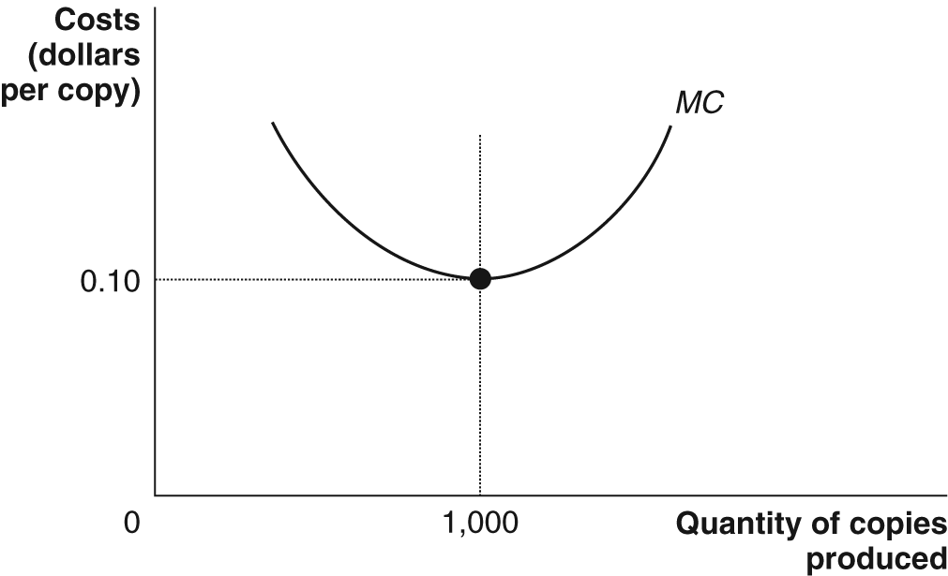

Step 3: Draw the AVC curve for Bill’s Store. Start drawing the AVC curve by selecting a point on the MC curve you drew. Draw the right half of another U from this point, then go back to the starting point and draw the left half of the U representing AVC. Note that each half of this U is drawn upward, to the right and to the left, so that its lowest point is on the MC curve. Label the AVC curve.

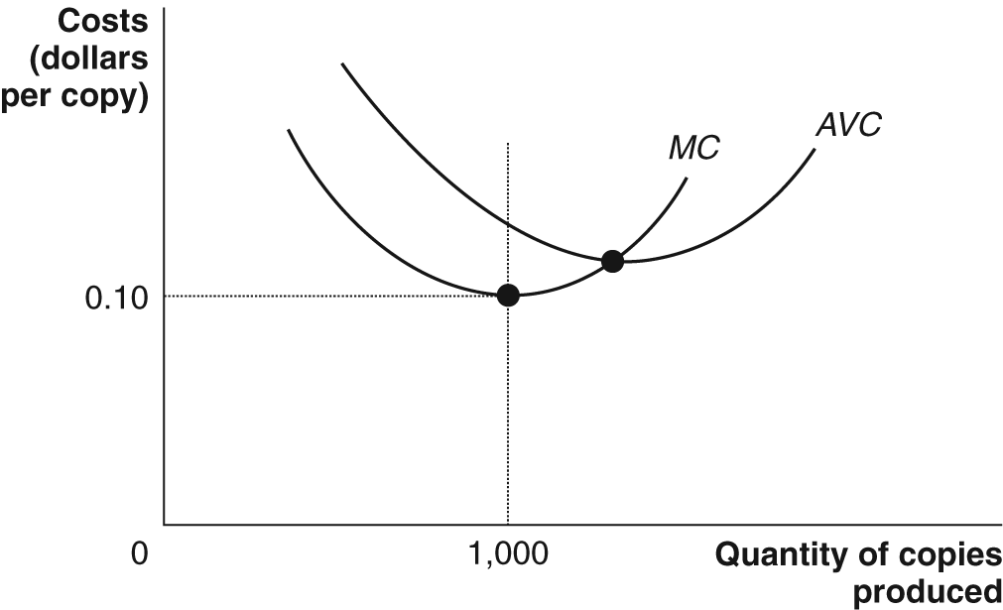

Step 4: Draw the ATC curve for Bill’s Store. Repeat the procedure from Step 3 but be careful to (a) select a starting point on MC that is above the starting point for AVC; (b) be sure that the right half of the U becomes closer to AVC, as this half of ATC is drawn to the right; (c) be sure that the left half of the U becomes farther away from AVC, as this half of ATC is drawn to the left. Label this curve ATC.

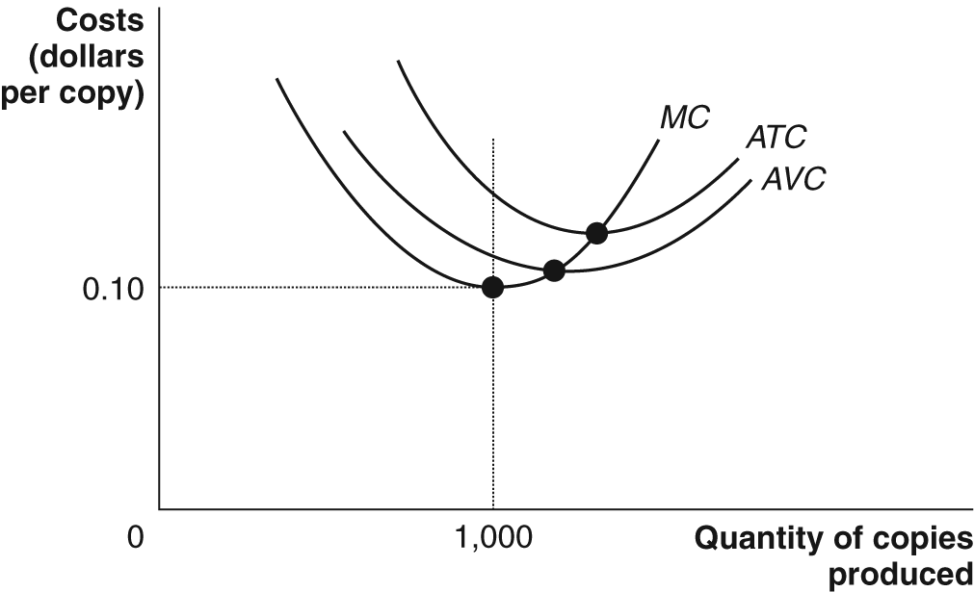

Step 5: Draw the AFC curve for Bill’s Store. Begin the AFC curve by selecting a cost well above 0.10 and near, but not equal to, 0 on the quantity axis. This curve will slope downward and will approach, but will not touch, the quantity axis far to the right of 1,000. Label this curve AFC. Note that the difference between ATC and AVC will equal the height of AFC at the same quantity.

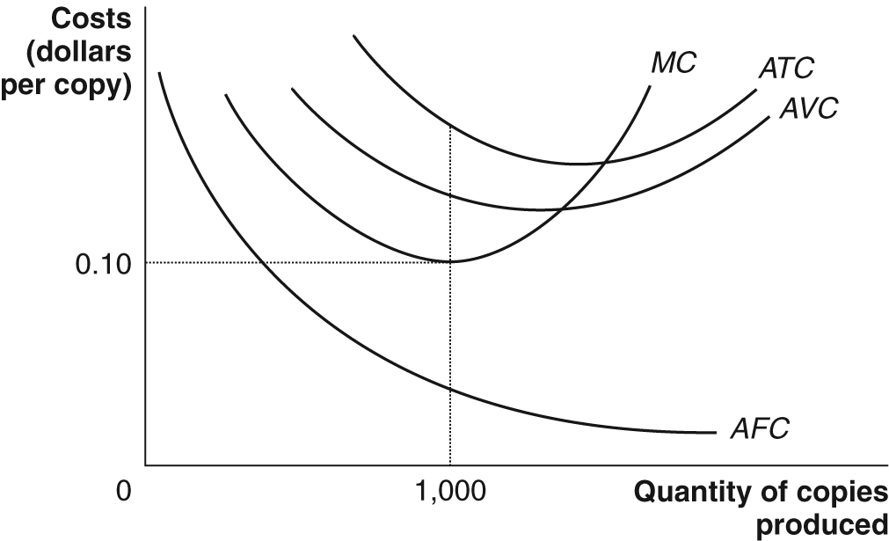

CHAPTER 10 Appendix
Using Isoquants and Isocosts to Understand
Production and Costs
Isoquants
1. Firms search for the cost-minimizing combination of inputs that will allow them to produce a given level of output.
- The cost-minimizing combination of inputs depends on technology and input prices.
- An isoquant is a curve showing all the combinations of two inputs, such as capital and labor, that will produce the same level of output.
- The higher an isoquant is – the further to the right on the graph – the more output the firm produces
- There are an infinite number of isoquants, one for every level of output.
2. The marginal rate of technical substitution (MRTS) is the slope of an isoquant; it represents the rate at which a firm is able to substitute one input for another, while keeping the level of output constant.
- The slope of an isoquant becomes less steep as one moves downward. This is a consequence of diminishing returns to inputs.
►Teaching tips: Figure 10A-1 illustrates three isoquants, each of which represents various combinations of capital (measured on the vertical axis) and labor (measured on the horizontal axis) that enable Jill to produce a given number of photocopies per day. Isoquants are similar to indifference curves in several respects. Students who understand the analysis of indifference curves in the appendix to chapter 9 will understand isoquants.
Isocost Lines
1. The relationship between the quantity of inputs used and the firm’s total cost can be shown with an isocost line.
- An isocost line shows all the combinations of two inputs, such as capital and labor, that have the same total cost.
- An isocost line intersects the vertical axis at the maximum amount of an input (for example, capital) that can be purchased.
- An isocost line intersects the horizontal axis at the maximum amount of another input (for example, labor) that can be purchased.
- One input is substituted for another as one moves along an isocost line but the total expenditure on inputs is the same.

2. The slope of an isocost line is constant and equals the change in the quantity of one input (units of capital) divided by the change in the quantity of the other input (units of labor).
- The slope of an isocost line is equal to the ratio of the price of the input on the horizontal axis divided by the price of the input on the vertical axis, multiplied by negative 1.
- Higher levels of total cost shift the isocost line outward, and lower levels of cost shift the isocost line inward.
►Teaching tips: Figure 10A-2 illustrates an example of isocost lines. The analysis of isocost lines is similar to the analysis of budget lines in the appendix to chapter 9.

Choosing the Cost-Minimizing Combination of Capital and Labor
1. There is only one combination of inputs that will produce a given amount of output at the lowest total cost.
- The lowest cost combination of inputs that will produce a given level of output is found at the tangency of an isocost line with the isoquant that represents the given output level.
2. The cost-minimizing choice of inputs is determined jointly by available production technology and input prices.
- A change in technology affects the position of isoquants and may affect the choice of inputs.
- If input prices change, the position of isocost lines would change, and the choice of inputs may also change.
3. At the point of cost minimization, the marginal rate of technical substitution (MRTS) is equal to the price of the input measured on the horizontal axis (for example, the wage rate or price of labor) divided by the price of the input measured on the vertical axis (for example, the rental price of capital).
- The slope of an isoquant is the rate at which a firm can substitute labor for capital given the existing technology.
- The slope of an isocost line is the rate at which a firm is able to substitute labor for capital at given current input prices.
- Moving along an isoquant, the amount of inputs used changes but output stays the same.
- The marginal product of capital (MP_{K}) equals the change in output from using an additional unit of capital.
- The marginal product of labor (MP_{L}) equals the change in output from using an additional unit of labor.
- The change in output from moving down an isoquant is equal to:
- Δ quantity of capital x MP_{K} = Δ quantity of labor x MP_{L}.
- Rewriting this equation:
- Δ quantity of capital = MP_{L}
Δ quantity of labor MP_{K}
- MRTS = MP_{L}
MP_{K}
- The slope of the isocost line equals the wage rate (w) divided by the rental price of capital (r). At the point of cost minimization, the slope of the isoquant equals the slope of the isocost line. Therefore:
- MP_{L} = w
MP_{K} r

- MP_{L} = MP_{K}
w r
- The last equation implies that to minimize cost, a firm should hire inputs up to the point where the last dollar spent on each input results in the same increase in output.
►Teaching tips: Assign Making the Connection 10A-1 and Solved Problem 10A-1 to help students understand the material in this section. Problems and Applications number 3 is related to Solved Problem 10A-1.
The Expansion Path
1. An expansion path is a curve showing a firm’s cost-minimizing combination of inputs for every level of output.
- The expansion path represents the least-cost combination of inputs to produce a given level of output in the long run when the firm is able to vary the levels of all of its inputs.
- In the short run, one of the firm’s inputs is fixed. Expansion of output is possible only by varying the firm’s variable input(s).
- The firm’s minimum total costs of production are lower in the long run than in the short run.
►Teaching tips: Figure 10A-6 offers an illustration and description of the expansion path.

5. Solutions to Review Questions and Problems and Applications
Answers to Thinking Critically Questions
1. An eighth-generation factory is likely to use even more advanced technology, so the minimum point on its long-run average cost curve will be even lower than for the seventh-generation factory. (If this minimum point isn’t lower, companies will stick with the seventh-generation technology.)

2. Increases in engineering skills will enable firms to develop more efficient processes for designing and producing products like LCD screens. This will lower the LRAC curve.

Answers to Review Questions

1. Technology is the process a firm uses to turn inputs into outputs of goods and services. Technological change is a change in the ability of a firm to produce a given level of output with a given quantity of inputs. Technological change could be negative, such as when regulations require the firm to adopt less efficient methods of production, when a natural disaster hits, or when a firm hires less-experienced workers.

2. In the short run, at least one of the firm’s inputs is fixed, but in the long run the firm can vary all of its inputs, adopt new technology and change the size of its physical plant. The amount of time that it takes to get to the long run varies from firm to firm.

3. Explicit costs involve spending money. Implicit costs are nonmonetary opportunity costs, such as the wages that the owner of a firm could have earned if he or she worked for someone else.

4.

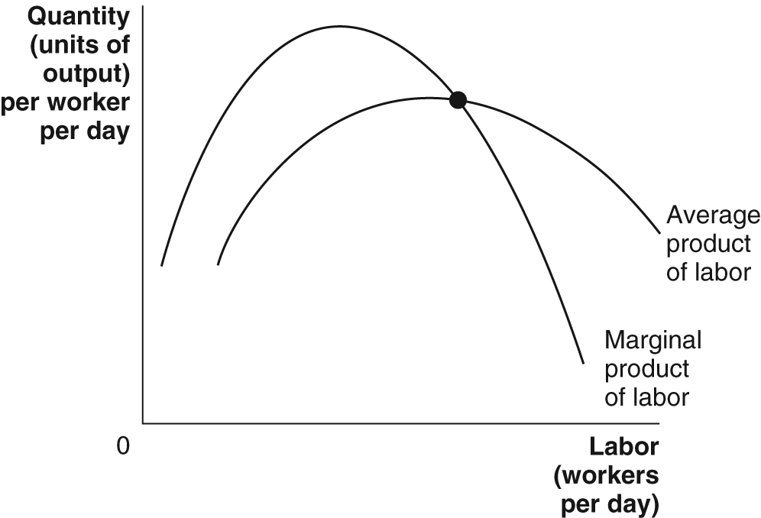

Marginal product normally increases at first due to specialization and division of labor, but it eventually falls because the amount of capital per worker falls as more labor is hired to work with a fixed amount of capital. When the marginal product of labor is greater than the average product of labor, the average product of labor increases. When the marginal product of labor is less than the average product of labor, the average product of labor is pulled down and decreases.

5. The law of diminishing returns is the principle that, at some point, adding more of a variable input (for example, labor) to the same amount of a fixed input (such as capital) will cause the marginal product of the variable input to decline. It doesn’t apply in the long run because in the long run none of the inputs are fixed; all can vary.

6. If the marginal product of the last worker hired is greater than the marginal product of the next-to-last worker hired, then the marginal product of labor curve is still sloping upward and the marginal cost curve is still sloping downward. It is rare for a firm to produce at a level where its marginal cost curve is still falling, but this can happen.

7. When marginal costs are below average, they pull average variable costs down, so we are on the downward-sloping section of the U-shaped average variable cost curve. When output expands enough, marginal costs rise to equal and then exceed average variable costs. When marginal costs are above average, they pull average variable costs up, so we are on the upward-sloping section of the U-shaped average variable cost curve. Thus, at the point where marginal costs equal average variable costs, the average variable cost curve stops sloping downward but hasn’t begun sloping upward – that is, the average variable cost curve is at its lowest point when the marginal cost curve equals (or intersects) it.

8. In the short run, total cost = variable cost + fixed cost; but in the long run, total cost = variable cost because there are no fixed costs in the long run.

9. Minimum efficient scale is the lowest level of output at which all economies of scale have been exhausted – that is, where the long-run average cost curve stops sloping downward. In the long run, firms that don’t reach minimum efficient scale will have higher average costs than competitors that do, so they will probably be driven out of business.

10. Economies of scale exist when a firm’s long-run average costs fall as the firm increases output. Diseconomies of scale exist when a firm’s long-run average costs rise as the firm increases output. Diseconomies of scale eventually arise because managing a store or factory above a certain size is simply too complicated.

Answers to End of Chapter Problems and Applications

1. b., c., and d. are examples of positive technological change. Cases a. and e. aren’t, because the same amount of inputs are used to produce the same amount of output.

2.
Quantity of Workers | Total Output | Marginal Product of Labor | Average Product of Labor
0 | 0 | — | —
1 | 400 | 400 | 400
2 | 900 | 500 | 450
3 | 1500 | 600 | 500
4 | 1900 | 400 | 475
5 | 2200 | 300 | 440
6 | 2400 | 100 | 400
7 | 2300 | –100 | 329

3.

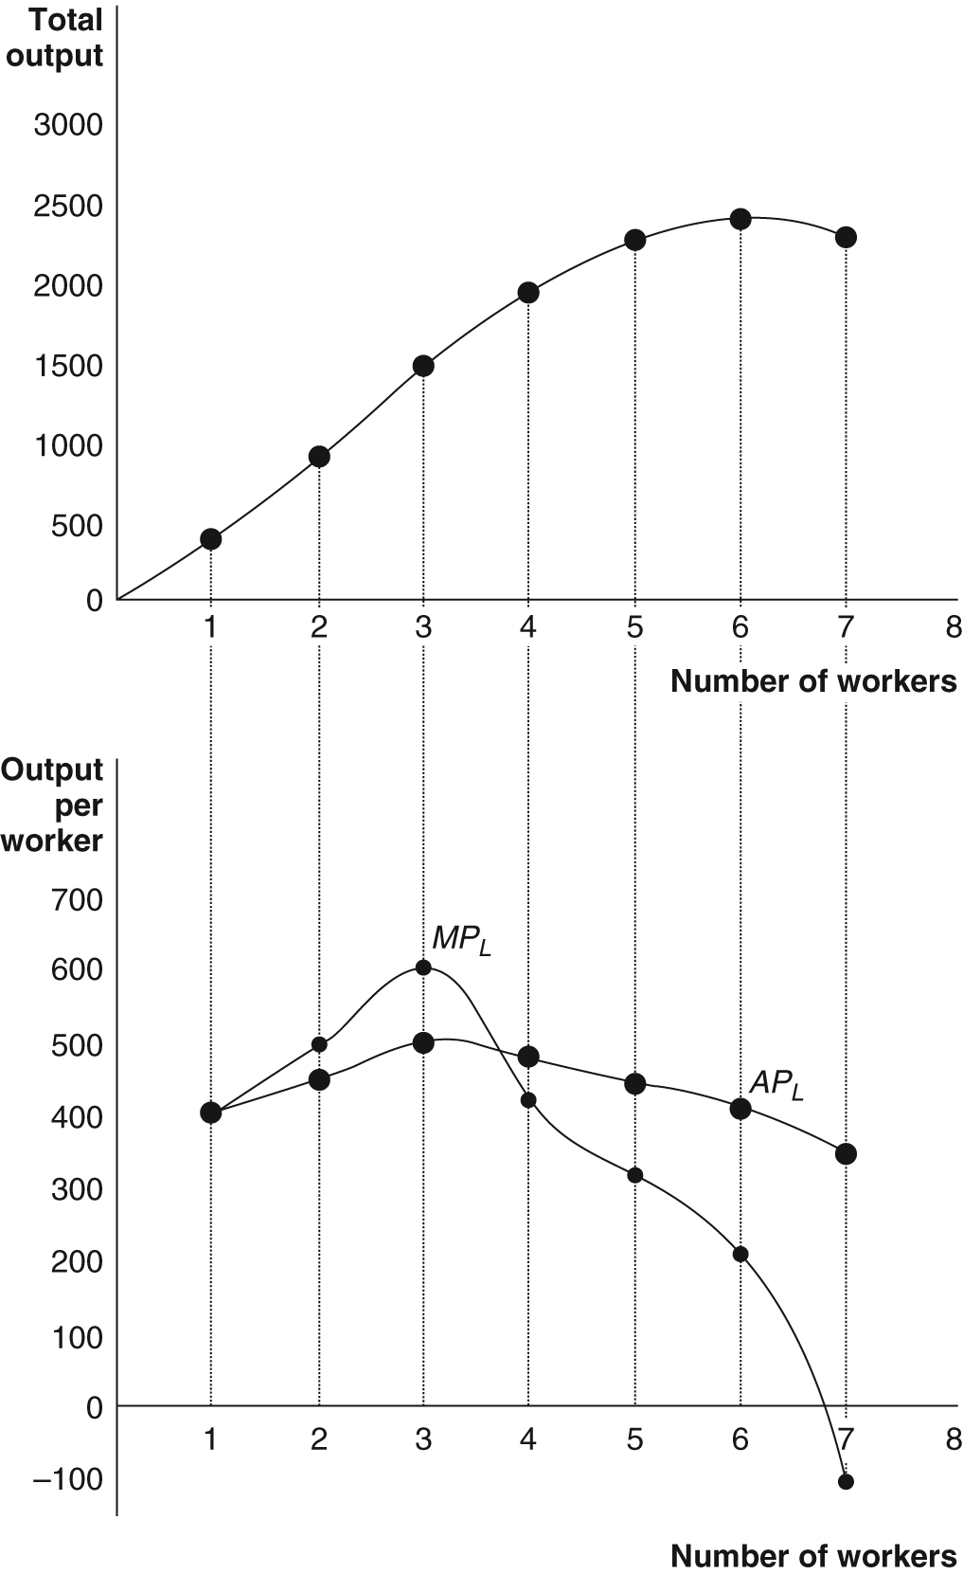

4. a. Variable cost = total cost – fixed cost = $30,000 - $10,000 = $20,000.
b. AVC = VC/Q = $20,000/10,000 = $2; AFC = FC/Q = $10,000/10,000 = $1
c. The gap must get smaller as output rises because ATC = AVC + AFC and AFC falls as output rises.

5. The student’s analysis is incorrect. The data in Table 10-3 represent the effects of specialization and division of labor, and the law of diminishing returns, not the varying quality of the workers.

6. As long as Sally’s GPA for a semester is below her cumulative GPA, her cumulative GPA will fall.

7. No. Anything that increases the marginal product of labor must also increase the average product of labor.

8. Jill’s reasoning is faulty. If she could rent out her current building for $4,000 per month, then she incurs an opportunity cost of that amount by using the building herself.

9. The report included expected earnings as a loss because the return on the investment represents the opportunity cost of the funds the company had invested. Expected earnings is an implicit cost, but it still needs to be included when calculating the true economic profit or loss.

10. Although Franklin had no explicit expense when he advertised in his own paper, he did incur a cost. The space for his own advertisements could have been used for paid advertisements by other firms.

11. Average total cost is total cost divided by total output. In this case, average total cost is $750.02/20,001 = $0.0375. Marginal cost is the change in total cost divided by the change in output. In this case, marginal cost is $0.02/1 = $0.02. As the graphs show, when average cost is greater than marginal cost, marginal cost may be either decreasing (graph (a)) or increasing (graph (b)). Therefore, Jill is wrong to say that her marginal cost must be increasing.

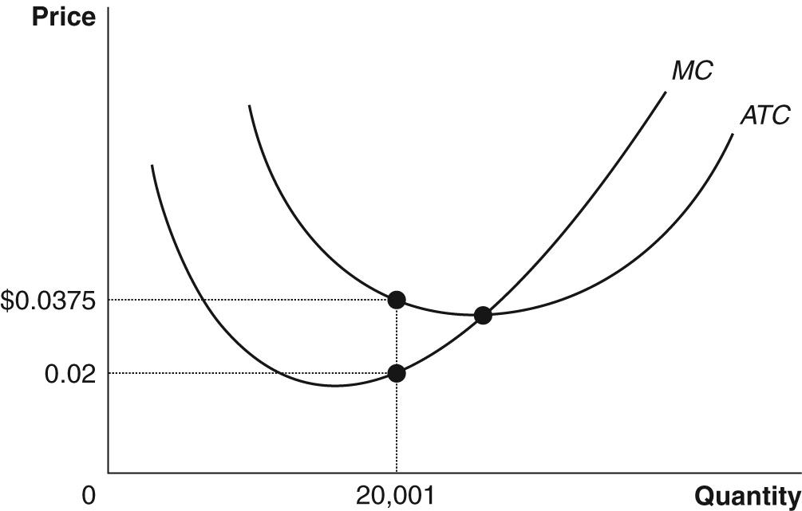
(a) In this case, Jill’s average cost is above her marginal cost, and her marginal cost is decreasing.

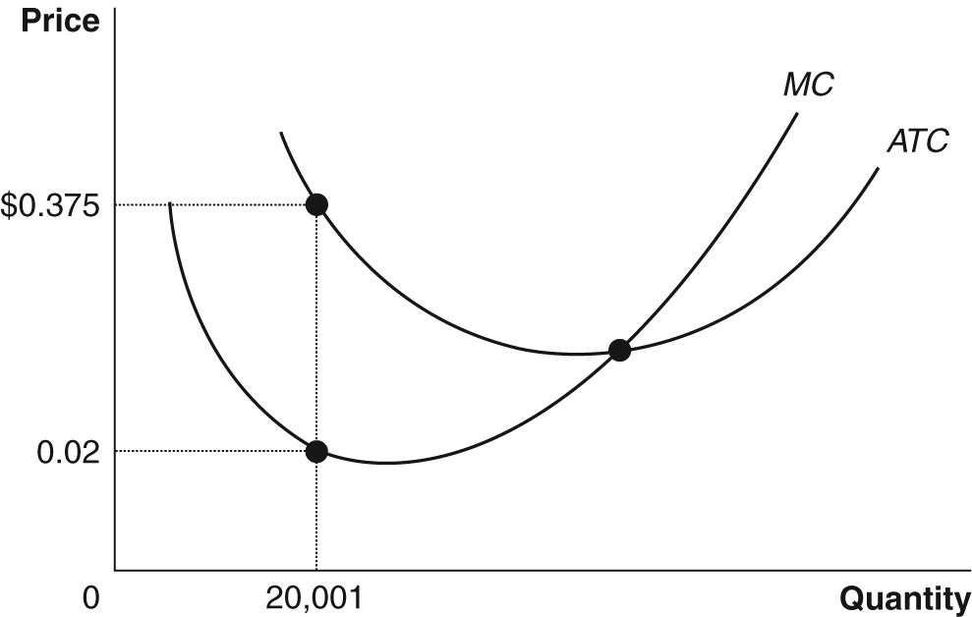

(b) In this case, Jill’s average cost is above her marginal cost, and her marginal cost is increasing.

12. Fixed costs are like a lump-sum tax because both are fixed amounts that do not change as output changes. Because AFC = FC/Q, a tax becomes smaller per unit of output as output rises.

13. a. For five copies, the total cost of five scrolls would be equal to the variable costs of 27.83 x 5 = 139.15, because there are no fixed costs. The total cost of five codexes would be the sum of the variable costs of 20.58 x 5 = 102.9 plus the fixed costs of 58, or 160.9. So, the publisher should publish the book as a scroll. For ten copies, the total cost of ten scrolls would be equal to the variable costs of 27.83 x 10 = 278.3. The total cost of ten codexes would be the sum of the variable costs of 20.58 x 10 = 205.8 plus the fixed costs of 58, or 263.8. So, the publisher should publish the book as a codex.
b. As publishers began to publish more copies of each book, it was cheaper to publish books as codexes.

14. a. Jill’s costs will be lower with a smaller store.
b. Her costs will be lower with a larger store.
c. Because of the effects of economies of scale.

15. a. $15
b. Total cost = ATC x Q = $30 x 1000 = $30,000.
c. Variable cost = AVC x Q = $20 x 1000 = $20,000.
d. Fixed cost = Total cost – variable cost = $30,000 - $20,000 = $10,000.

16. AFC should be downward sloping, not U-shaped. ATC should be above AVC.

17. a. marginal cost, average variable cost, and average total cost will all increase; average fixed cost is unaffected
b. marginal cost, average variable cost, and average total cost will all increase; average fixed cost is unaffected
c. average fixed cost and average total cost will increase; marginal cost and average variable cost will be unaffected
d. average fixed cost and average total cost will increase; marginal cost and average variable cost will be unaffected.

18. Ford would have ended up as the only automobile producer. Other producers would have had higher costs and, therefore, would not have been able to match his price cuts.

19. a. The minimum point on the oil refinery’s long-run average cost curve came at a level that was a much higher fraction of industry output than in the shoe industry.

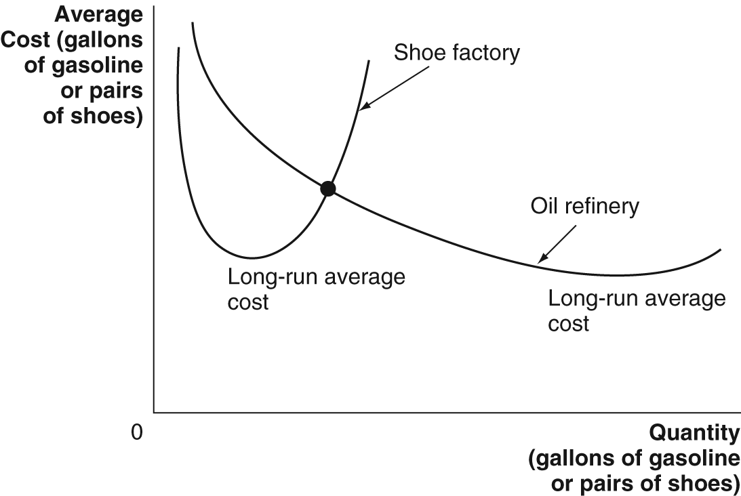

b. There were more shoe factories than oil refineries in the late 19th century, because the economies of scale in oil refining meant that large oil refineries had a significant cost advantage over small oil refineries. Economies of scale in shoe manufacturing were much more limited.
c. Because these very large shoe factories would have suffered from significant diseconomies of scale.

20. There must be economies of scale in book publishing.

21. The statement is incorrect. The River Rouge plant exhibited diseconomies of scale – a long-run concept – not diminishing returns – a short-run concept.

22. Morita’s short-run cost curve is described in the chapter opener. Its lowest point is at outputs between 10,000 and 30,000. If he wanted to produce more than 75,000, he would have built an additional factory, or, if there were economies of scale in manufacturing transistor radios, he would have built a larger factory.

23. Companies with greater economies of scale have lower costs than competitors, so they can charge a lower price and still turn a profit.

24. eToys built the large distribution center represented by ATC₂ because they expected their sales to be Q₂. In that case, their average costs would have been AC₁. In fact, their sales were only Q₁, which meant their costs were AC₃. If they had known how low their actual sales would have been, they would have been better off building the smaller distribution center represented by ATC₁. This would have lowered their average costs to AC₂. This is what the author meant when he wrote that eToys “needed to generate much higher sales to justify its costs.”

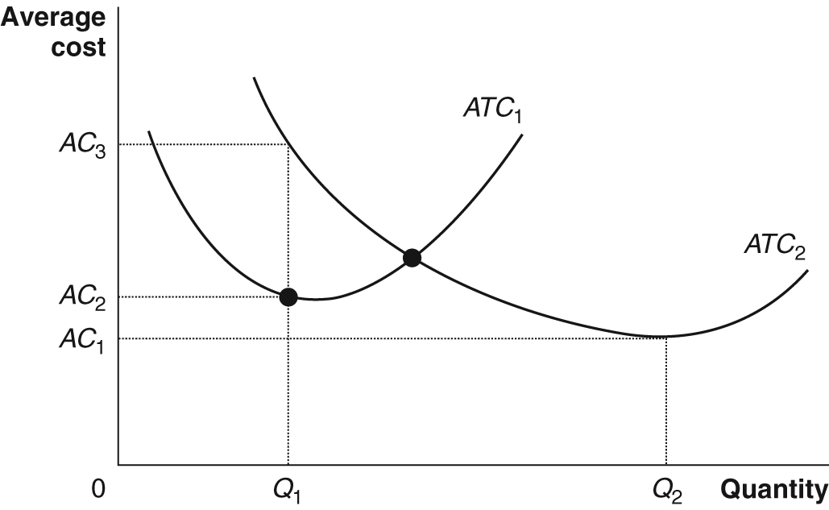

25. CNN and ABC News were on ATC₁. If they had merged, they would move to ATC₂ and be on the section of the long-run average cost curve that exhibits diseconomies of scale.

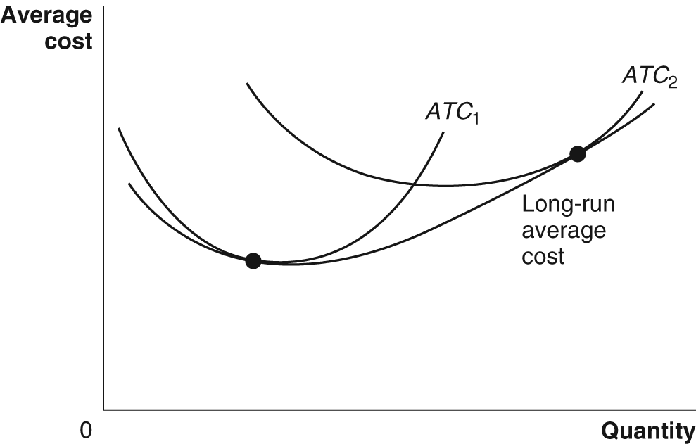

26. DuPont had expected to be on ATC₁, in which case as production of paint increased from Q₁ to Q₂, average cost would have decreased from AC₁ to AC₂. In fact, they were on ATC₂, so average cost actually increased from AC₃ to AC₄, as production expanded.

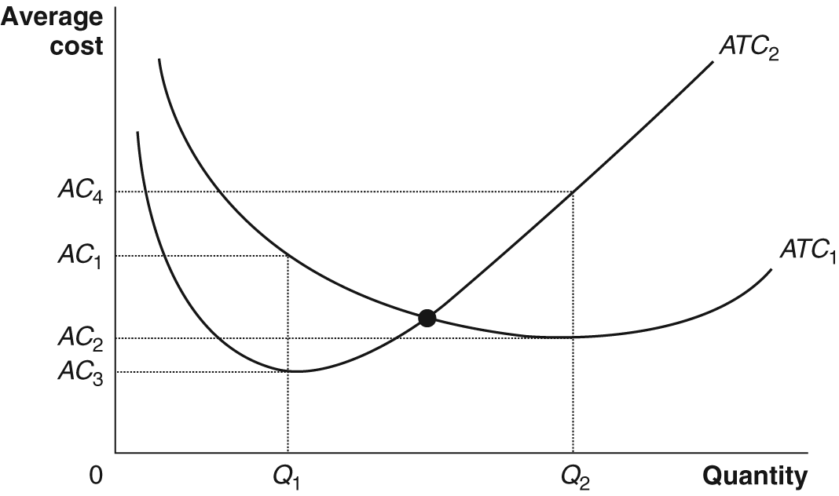

27. If the smaller plants’ average costs are higher, they cannot make a profit selling at the market price – which will equal the average cost of the more efficient plants.

28. The investors were expecting the long-run average cost curve to fall as output rose from the initial level, Q₁, to the post-merger level Q₂, as shown by LRAC₂. Instead, long-run average costs didn’t fall. LRAC₁ reflects the actual long-run average cost curve because average costs are no lower at Q₁ than at Q₂.

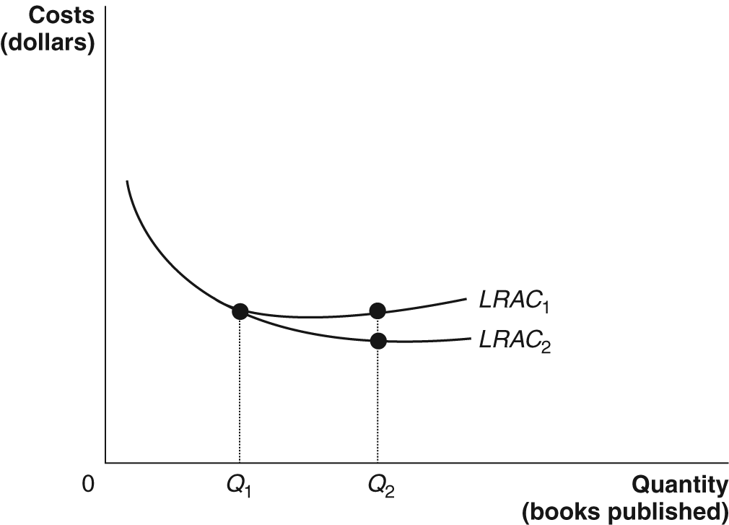

29a. ΔVC = wΔL
b. 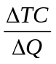 = 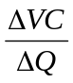 = 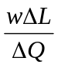= 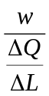,
or
MC = 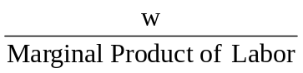

c. If w = $75, then
MC = 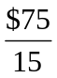= $5.

If wage falls to $60, then
MC = 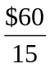= $4.

If wage is $75 and marginal product rises to 25, then
MC = 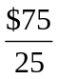 = $3.

Answers to Appendix Problems and Applications

1.

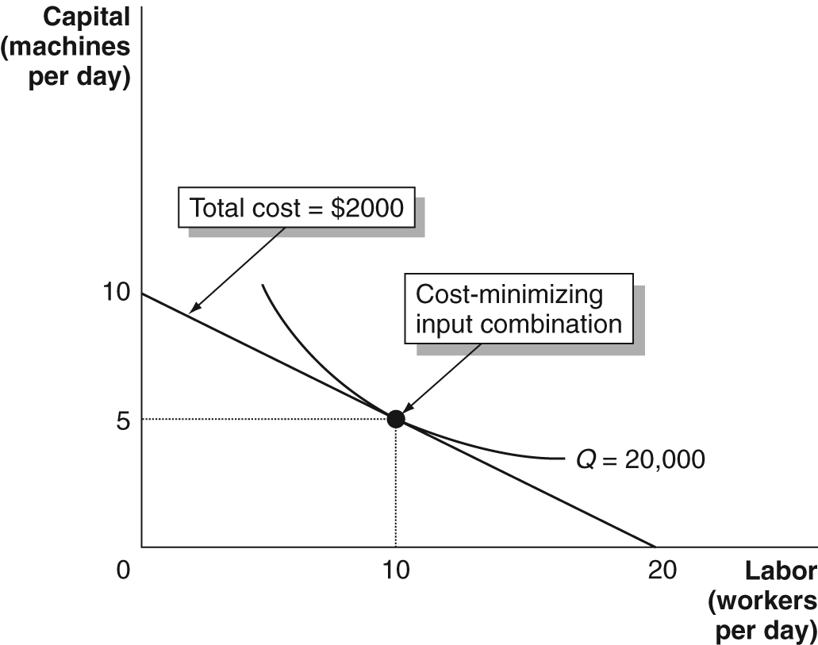

2. a. If total cost is $2000 and wage and rent price = $100, the isocost curve’s endpoints are at 20 and 20. Along this isocost curve, the cost-minimizing point for producing 5000 copies is at point A.
b. If wage rate is one-fourth the rental price of capital, then we must be on the isocost curve whose endpoints are where capital = 10 and labor = 40 – since we can buy four times as much labor, with total cost of $1,000. Along this isocost curve the cost-minimizing point for producing 5000 copies is at point B.
c. In this case the isocost curve’s endpoint are at 40 and 40, so the cost-minimizing point for producing 12,000 copies is at point C.

3. To minimize costs Jill should be at a point where
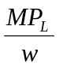= 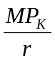.

Plugging in the numbers we get:

=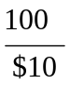= 10 and =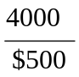= 8.

Unfortunately the ratios are not equal, so Jill isn’t minimizing costs. If she hired more workers and rented fewer machines, her 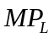would fall and her 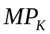 would rise until = .

4. Positive technological change will enable Jill to produce 20,000 copies with fewer inputs than before. The isoquant curves will shift inward. Along the new Q* = 20,000 isoquant, she can produce 20,000 copies with fewer inputs than before – for example, 9 workers and 4 machines at point B. At her initial input level, point A, she will be able to produce more than 20,000 copies – in this example, she can now produce 22,000 copies using 10 workers and 5 machines. (The shapes of the isoquant curves may change, as well, but this isn’t shown here.)

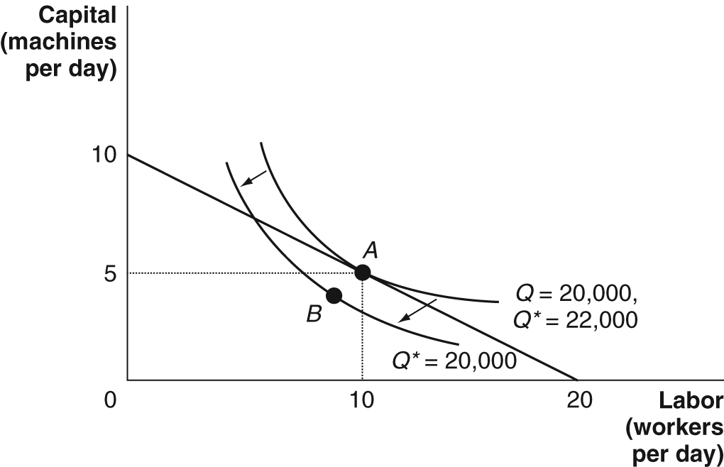

5a. Combinations A and B yield the same output, since they are on the same isoquant curve.

b. The ratio of the wage rate to the rental price of capital will determine which point along this isoquant Jill chooses.

c. The marginal rate of technical substitution is the slope of the isoquant, which is greater in magnitude at point A.

6.
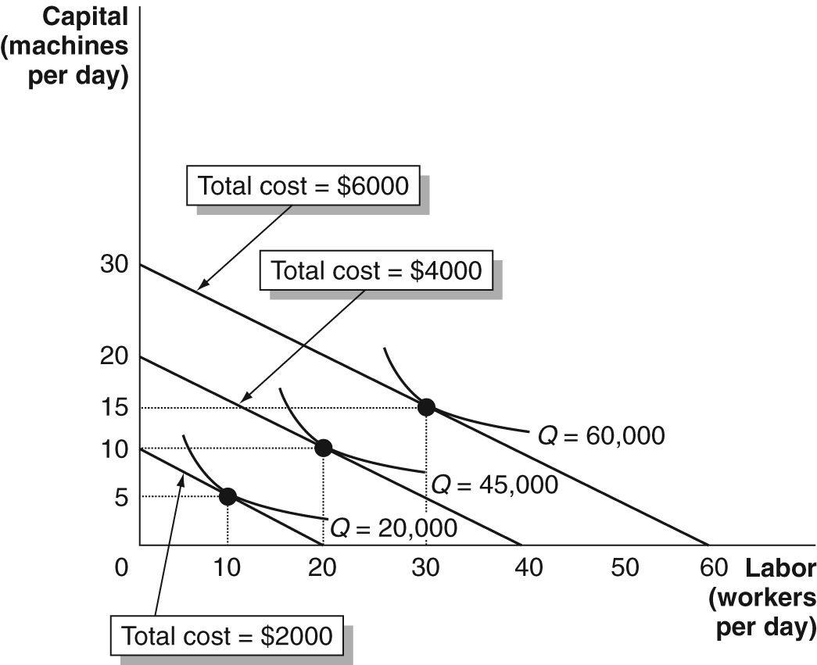

Long-run average cost = (total cost)/Q.
The long-run average cost curve exhibits economies of scale (average cost falling as output rises) up to 45,000 copies per day, but diseconomies of scale at levels higher than 45,000 copies per day.

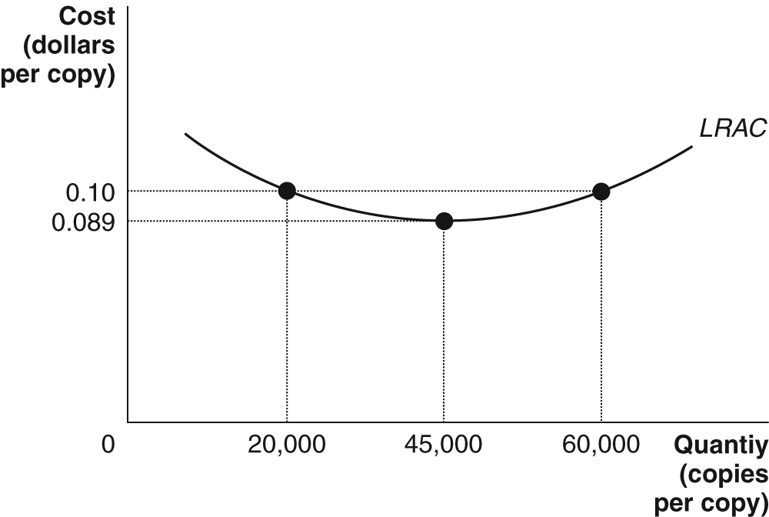

7. Because Jill’s MRTS equals –1, the slope of her isoquant at point A (5 machines and 10 workers) must be –1. However, the slope of the isocost curve isn’t –1, it is –1/2, so the isoquant curve isn’t tangent to the isocost curve and Jill isn’t minimizing costs. In order to minimize the cost of making 20,000 copies, she can move to a lower isocost curve that is tangent to the Q = 20,000 isoquant curve. This would be at point B, where she uses more labor and less capital.

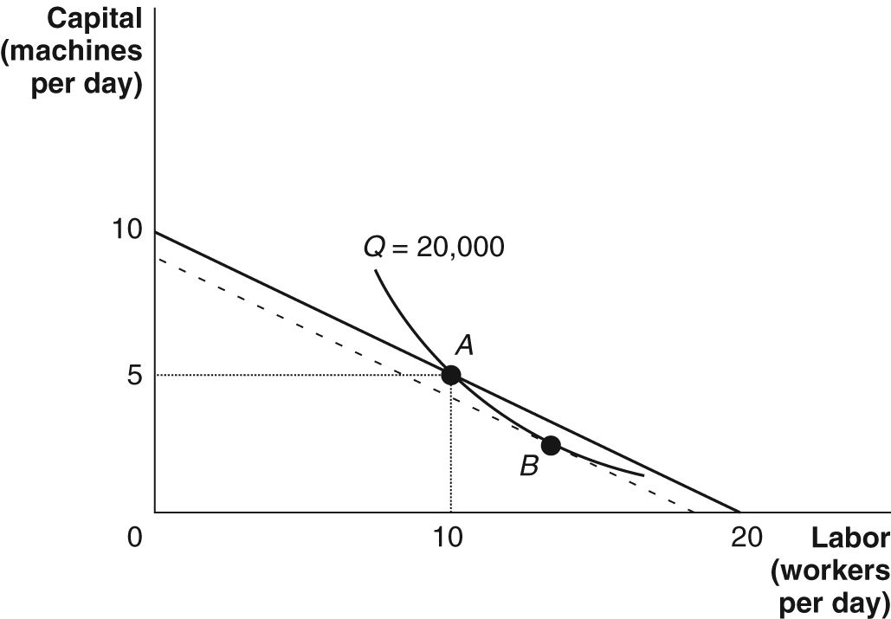

8. The isoquant curve shows that there are innumerable combinations of workers and machines that can pick the same quantity of oranges per day. In the U.S., firms select a point like A – using a lot of capital and very little labor – because the isocost curves they face are very steep, due to the fact that labor is relatively expensive in comparison to capital in the U.S. In Brazil, firms select a point like B – using lots of labor and very little capital – because the isocost curves they face are very float, due to the relatively low price of labor in comparison to capital in Brazil.

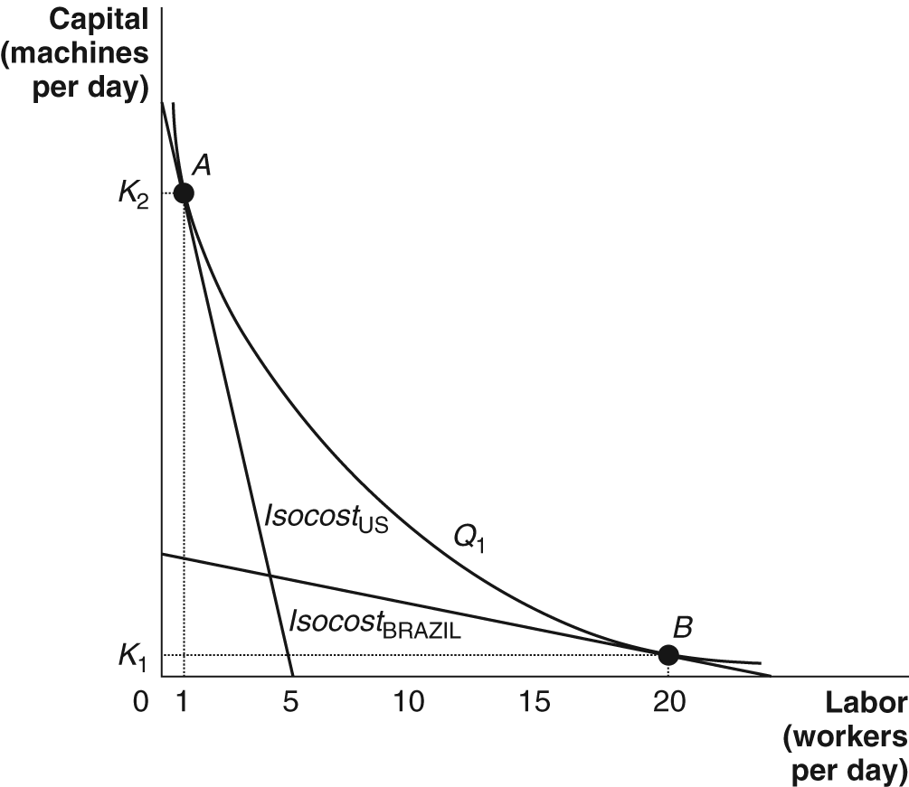

9. If Jill is minimizing costs,
= .

Plugging in these numbers:

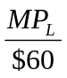= 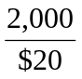.

Solving this:
= $60 x = 6,000 copies/workers.

